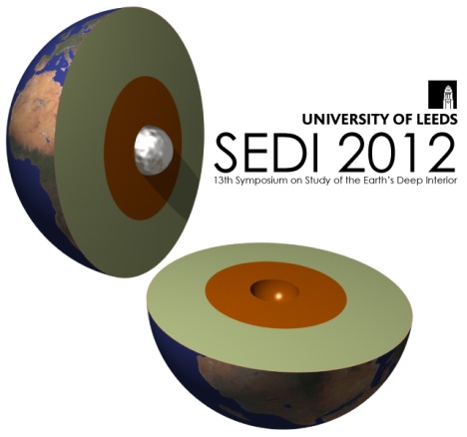**Application for Offline Payment for**

**13th Symposium on**

**Study of the Earth’s Deep Interior**

**University of Leeds, 1 - 6 July 2012**

*http://sedi2012.leeds.ac.uk*

**Your Details** Please provide the following details (* required field):

|  |  |  |
| --- | --- | --- |
| Email Address* |  | |
| Title* |  | |
| First Name* |  | As you’d like these to appear on your badge |
| Last Name (Family Name)* |  |
| Organisation |  |
| Contact Telephone Number* |  | |

|  |  |
| --- | --- |
| Home Address |  |
| House/Flat Number/Name* |  |
| Postcode/Zipcode* |  |
| Country* |  |

|  |  |
| --- | --- |
| Billing Address | leave blank if same as above |
| House/Flat Number/Name |  |
| Postcode/Zipcode |  |
| Country |  |

**Special Requirements** *please state “none” if you do not have any*

(e.g. access or diets)

|  |
| --- |
|  |

**Data Protection**

The information you give on this form will be used to process your registration at the conference and will not be passed on to any other bodies. Your contact details may be passed on to the organisers of the next conference – please tick if you do not want to receive details of this

Your name, affiliation and email address will be included in a list of attendees which will be available to conference delegates – please tick if you do not wish to be on this list or want only some of your details to be included

Please give further details: I do not want my       to be listed

**Conference Registration**

|  |  |  |  |  |  |  |
| --- | --- | --- | --- | --- | --- | --- |
| *please circle/highlight as appropriate* | *Early-Bird*  *Before 1 May 2012* | | *Regular*  *2 May – 1 June 2012* | | *Late*  *After 1 Jun 2012* | |
| Full | £270 |  | £330 |  | £370 |  |
| PhD Student | £210 |  | £270 |  | £310 |  |

Registration fees include: arrival Reception, all day-time catering (incl lunches) Mon morning - Fri morning, but excluding during the Weds afternoon excursion. Dinners and accommodation are not included, see below for options.

**Accommodation (Bed and Breakfast) at Charles Morris Hall on campus**

*http://sedi2012.leeds.ac.uk/SEDI_2012_accommodation.html*

|  |  |  |  |  |
| --- | --- | --- | --- | --- |
| *please put a cross in the box as appropriate* | *Ensuite student-style single-bed in Dobree House*  **Students Only** | | *Ensuite double-bed in brand-new Storm Jameson Court* | |
| Sunday 1st July 2012 | £35 |  | £44 |  |
| Monday 2nd July 2012 | £35 |  | £44 |  |
| Tuesday 3rd July 2012 | £35 |  | £44 |  |
| Wednesday 4th July 2012 | £35 |  | £44 |  |
| Thursday 5th July 2012 | £35 |  | £44 |  |
| Friday 6th July 2012 | £35 |  | £44 |  |
| I will make my own accommodation arrangements | | | |  |

**Conference Gala Dinner** *3-course Dinner at York National Railway Museum including drinks and transport to and from the venue*

|  |  |  |  |
| --- | --- | --- | --- |
| *please circle/highlight* | *I will be attending* | | *I will not be attending* |
| Wednesday 4th July 2012 | £35 |  |  |

|  |  |
| --- | --- |
| **Total Cost** |  |

**You will receive an emailed invoice for the total cost shown above.**

**Purchase order number if applicable:**

|  |
| --- |
|  |

**Cancellations**

Cancellations will be charged at the following rate: Up to 31 March a fee of £25.00 will apply. Up to 31 May - 30% of fee paid. After 1 June - 75% of fee paid. 1 week before Conference a 100% charge will apply. Substitutions can be made at any time.

If you have any queries, please don’t hesitate to call us on **0113 343 6104**.

Please return this form to: Conference & Events Office, 3rd Floor, University House, University of Leeds, Leeds, LS2 9JT

or by return of email to the sender, or to [sedi2012@leeds.ac.uk](mailto:sedi2012@leeds.ac.uk)