Standard Operating Procedure for:  Using the freeze drier | PPE required:
Samples should be in containers such as centrifuge tubes or petri dishes with clear sides so the rate of drying can be monitored. Samples must be pre-frozen. If you want to know the sample moisture content then you should weigh them before freezing. If they become iced it will affect the length of time needed to dry a sample. In general, sample thickness should be less than 10mm.
Do not over load the drier with samples, separate into batches if necessary.
Ensure samples are covered to stop dusting /contamination in the chamber and across samples. This can be done with tissue paper secured over the top of samples with an elastic band. Use of the samples are risk assessed prior to work.
Preparing freeze drier for use  - Make sure the drier has been off for at least 12 hours since last use.  - Remove Perspex top and rest on the bench (upside down).  - Check seals are clean and free from any dirt. Wipe gently with ethanol if they are dirty.  - Check the bottom of the condenser chamber is dry and the Drain Valve is closed. Dry chamber with tissue if wet.  - To pre-cool the dryer to -110°C or lower (left-hand gauge), switch on the freezer (green switch). Wait at least 30 minutes before operation the dryer.  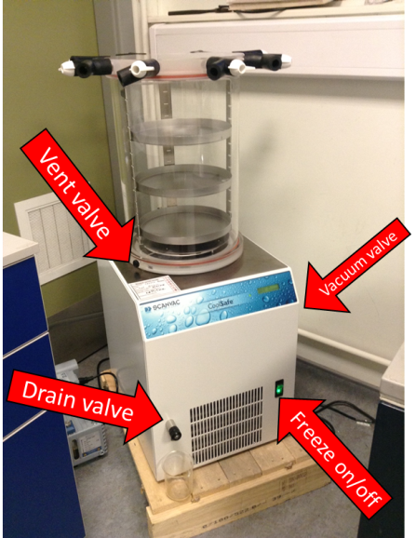  Starting the dryer  - Load the samples onto the trays and load into freeze dryer  - Replace Perspex top and make sure all valves are closed,  - Open the Vacuum pump Valve (black valve at back of dryer).*  - Write contact information and dates on form.  - Come back after 30mins to check the pressure is dropping  - Check the state of samples twice a day (am and pm) and turn off the dryer as soon as the samples are dry.  Stopping the dryer  - When samples are dried close the vacuum pump valve and slowly open the Vent Valve (on bottom Perspex piece) to admit air in to the system.  - Remove the chamber lid and take out samples.  - If samples are not totally dry place on the trays, replace in chamber close Vent Valve and reopen Vacuum pump Valve. Do NOT add to the chamber when there are already samples inside.  - If no more samples are to be dried switch the refrigerator off and open the Drain Valve to remove any water from the condenser chamber. Place container under the drain to collect water.  - Leave for 12 hours before using again to allow ice to melt.  * If vacuum pump is off make sure the valve is closed before you turn on the pump. | Hazard symbols:
Significant hazards:
E
OTHER HAZARDS MAY ARRISE FROM INDIVIDUAL EXPERIMENTS.
Hazard phrases (H):
H225, H319
Can it be done out of hours?

Freeze dryer should not be loaded or unloaded out of hours. However, the freeze drier can be left in operation out of hours.
This SOP is not relevant in the following circumstances:
- SOP does not cover specific experimental risk these must be covered by user’s assessments
- Any other situation where the procedure may result in harm to yourself or others.

