Standard Operating Procedure for:  Using the LECO | PPE required:
The LECO is designed to determine the carbon and sulphur content of materials. It has a tube furnace kept at a constant 1350ºC with a pure oxygen atmosphere into which you place your sample. At this temperature the sample combusts releasing CO₂ and SO₂. The gases flow through two anhydrone tubes to remove water and a separate halogen trap. They then go through the IR detection cell to measure the concentration of CO₂ and SO₂. The instrument converts these measurements into percentage (or ppm) values taking into account the sample mass and calibration.
This first page highlights some of the key operations and safety considerations that you must make when using the LECO. More details can be found in the following pages.
Preparing samples and standards  Samples should be washed thoroughly to remove all traces of chlorine (and fluorine) and then thoroughly dried. To prepare samples:  - Place ceramic combustion boat on balance and tare mass  - Add sample or standard and record mass.  - Place sample boat on a tray and record position. DO NOT WRITE ON BOAT!  Running the LECO  High temperature of LECO means that tinted glasses must be worn as risk of eye damage.  - Check the individual experimental risk assessment for risks from samples  - Make sure that the O₂ gas cylinder is on and there is sufficient gas in the cylinder to allow you to complete your experiment.  - Enter sample and standard data into the software and click “analyze”  - When the software tells you it is ready open the door and slide the sample boat in quickly and close the door after. Make sure not to scrape bottom of ceramic tube – pointy end of insert rod upwards.  - Wait until the sample has run (software will stop collecting data) and then remove the sample carefully. Again making sure not to scratch bottom of tube.  - SAMPLE WILL BE HOT so leave sample on shelf until it is cool and only remove using the tongs provided  Shutting down LECO  - Complete the log book  - The computer, gas cylinder and LECO remain on and should not be switched off unless it is an emergency. In an emergency turn off LECO at the wall and shut off gas at the cylinder.  - Remove your cooled samples and dispose of contents as discussed below.  Cleaning sample boats  Due to high temperatures your sample will have changed composition so you should take this into account when disposing of powders (For example CaCO₃ CaO which is corrosive). The following procedure must followed for all standards and is recommended for all samples.  - Inside a fume cupboard scrape the powder from the boat into a plastic bag using a spatula,  - Seal the bag and label,  - Dispose of as hazardous waste. | Hazard symbols:  CaO
Significant hazards:
- Gas cylinders
- High temperatures
- CaO combustion product
Hazard phrases (H):
H315, H318, H320, H335
Can it be done out of hours?

The LECO should not be used out of hours.
This SOP is not relevant in the following circumstances:
- SOP does not cover specific experimental risk these must be covered by user’s assessments
- Any other situation where the procedure may result in harm to yourself or others.

Detailed SOP for LECO
Choosing calibration standards
The aim of the calibration is to produce a calibration curve covering the range of carbon/sulphur contents of the samples you are placing in the LECO. If you do not already know the approximate concentration of C or S in your samples run one representative sample to get a rough idea using the previous users calibration.
- Decide how much sample you can use per measurement. Ideally at least two measurements per sample. Normally, 0.3g of sample per measurement.
- Using the “Calibration_speadsheet” fill in min and max expected C and S concentration.
- Fill in the amount of sample per measurement
- Pick a standard which can be used in the range of interest and which is as similar to your sample as possible.
- Pick min. 6 standard masses to create your calibration curve from for C and S (12 standards in total unless standard mass ranges overlap then 10 is sufficient).
- For example, if you expect 1-2% C and have 0.3g you should use Low C soil (approx. 0.05g, 0.1g, 0.2g, 0.3g, 0.4g, 0.5g) giving 6 standards of the correct range for carbon.
- You should also include blanks (zero) (minimum 2) in your calibration curve.
Calculation of uncertainty
To find the uncertainty of your measurements, this should be done ideally each time you use the machine but for each set of samples would be sufficient.
- Pick one sample which is representative of your samples,
- Run this sample 6-10 times (min. 6),
- Calculate the mean and standard deviation,
- Use the standard deviation to calculate the confidence limit (normally 95%),
- Quote answer as mean value ± confidence limit (e.g. 10 ± 1).
Limits of detection measurement
This only needs to be carried out intermittently – or when measuring low concentrations. Previously measured values (3/7/2014): for carbon 0.01% and sulphur 0.005%.
1. Measure 5-10 blanks (min. 5),
2. Find the average and standard deviation of these readings,
3. The limit of detection can then be expressed as 3 x standard deviation.
Cleaning sample boats
Due to high temperatures your sample will have changed composition so you should take this into account when disposing of powders. Due to high temperatures your sample will have changed composition so you should take this into account when disposing of powders. The following procedure must be carried out for all standards and is recommended for all samples – check your risk assessment. Boats can be reused up to 4 times so long as there is nothing “stuck” to the crucible.
- Inside a fume hood scrape the powder from the boat into a plastic bag using a spatula.
- Seal the bag and label
- Dispose of as waste if required
Prepare samples and standards
Samples should be washed thoroughly to remove all traces of chlorine (and fluorine) and then thoroughly dried. You should run Blanks and Standards at the beginning and then 1-2 standards at regular intervals (about every 10 samples). The result of this should be check to be within the uncertainty of the standard (see table below for details).
- Check the individual experimental risk assessment for risks from samples
- Place ceramic combustion boat on balance and tare mass
- Add sample or standard and record mass.
- Place sample boat on a tray and record position. DO NOT WRITE ON BOAT!
Each run should consist of the following:
Item | Measurements | Notes
Blanks | 4-6 | Representative of the boats you are using
Make sure you “set as blank” at this stage
Zero blanks | 2 | To be used for calibration curve
Standards | 6-12 | Standards depending on what you are measuring
Calibrate at this stage
Samples | 10 | Run two of each sample if possible
Standards | 1-2 | Use these to check calibration – results should be within specified uncertainty.
Samples | 10 | Repeat…
Standards | 1-2

Starting up LECO
- Make sure that the O₂ gas cylinder is on and there is sufficient gas in the cylinder to allow you to complete your experiment. Normally gas cylinder it is left on.
- Choose the Method you want to use (TOC analysis or Total C&S) from the Methods button. Check that the:
  - Minimum Integration Time = 60
  - Maximum Integration Time = 180
  - Comparator = 1
  - Blank at 1g is set by the computer (default is zero)
- If you want to change the method or change the standards please consult a technician.
- In the software click the “add sample” button and choose either a standard or enter a sample name. You should use the following standards:
Standard | Part no. | C% | S%
Low C soil | 502-062 | 1.99 ± 0.04 | 0.027 ± 0.003
High C soil | 502-814 | 22.8 ± 0.3 | 0.326 ± 0.011
CaCO₃ | 501-034 | 12.0
ZnS | 502-085 |  | 32.91
Coal | 502-671 |  | 1.01 ± 0.09
- Enter the mass for each of the standards and samples in the table. It should look something like this:
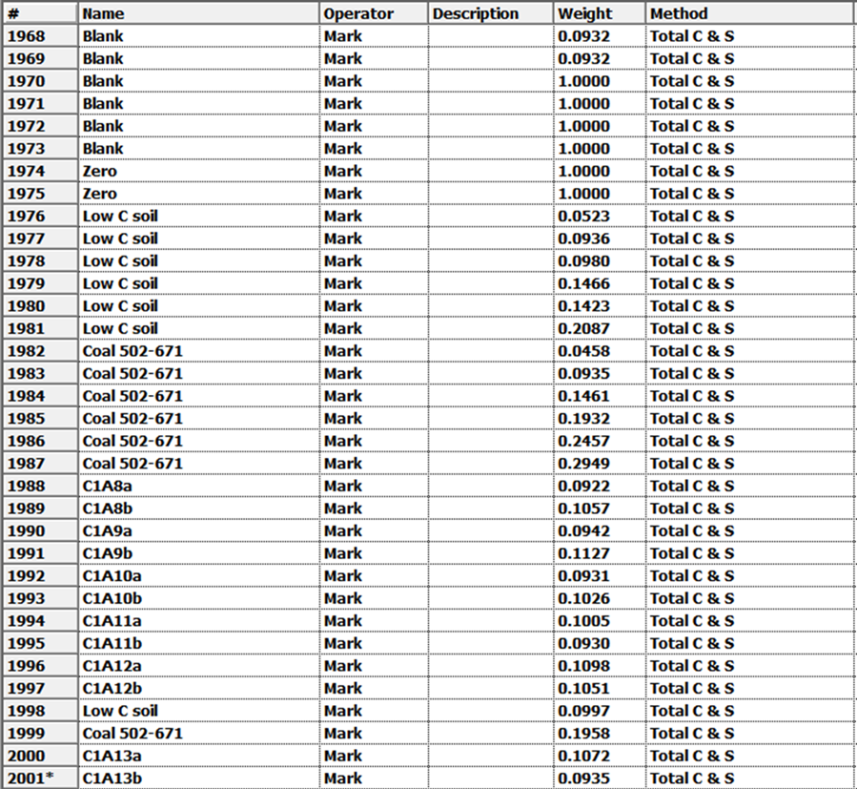

- Visually check the two anhydrone reagent tubes on front (at bottom). These should look powdery not “cakey”. If they look cakey it means they are wet and need replacing –SEE A TECHNICAN. Also, check that the fluorine/chlorine trap (tube to the right) is clean with the metal antimony shiny and the absorbent white (not yellow), again if it is yellow it may need replacing – SEE A TECHNICIAN.

Running a sample in
TINTED SAFETY GLASSES REQUIRED
Run the standards first and then before running samples make sure you have checked and renewed the calibration.
- In the software click “analyse”
- Wait for the baseline. An error window concerning IR cells may appear at this stage; in what case you should see a technician.
- Place the sample by the door on the combustion shelf
- When the software tells you it is ready open the door and slide the sample boat in quickly and close the door after. Make sure not to scrape bottom of ceramic tube – pointy end of insert rod upwards.
- Click “OK”
- Wait until the sample has run (software will stop collecting data) and then remove the sample carefully. Again making sure not to scratch bottom of tube.
- Leave sample on shelf to cool and prepare the next sample
- Only remove sample from platform when it is cool and only using the tongs provided
- After running the blanks, highlight the blanks, go to “tool”, select “set as blank”.
Calibrating the LECO
- Highlight all but the standards (including the “zero” standards).
- In the software click “calibrate”
- Check the calibration for the high sulphur, low sulphur and carbon. These should normally be on:
  - Weighting: normal
  - Curve: normally linear – not forced through origin
- Check for any obvious outliers. Only remove if you are convinced they are outliers. Do this by double clicking.
- Click “OK” and save the calibration
- If you have (re)calibrated after measuring some samples on the main screen highlight all the data, right click and “recalculate”.
Exporting data
Data can be exported as a text file by selecting the data you want and then going to Fileexport.

If you want to extract the graphs of the C or S peaks (the raw data for each measurement) select a sample and then go to FileProperties.

Shutting down LECO
- Complete the log book.
- The computer, gas cylinder, and LECO remain on and should not be switched off.
- Remove your cooled samples and dispose of contents as discussed above.

